7/26/2024

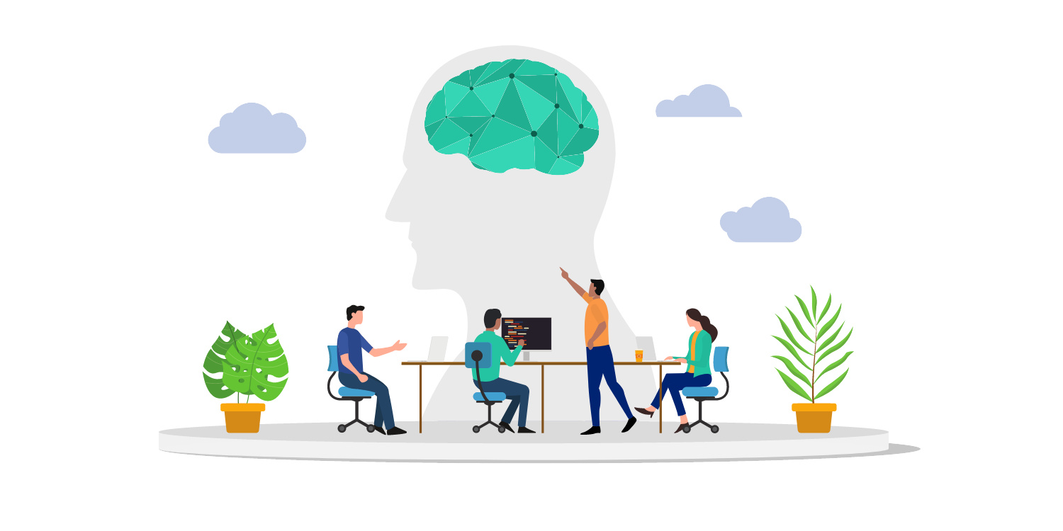

**Assignment**

**TIDKE ASHOK TATERAO**

nsti cALICUT

**Assignment Task-01**

**AIM:**

Lab 1 - NLP Preprocessing Technique

**Requirements:**

* Pc/Laptop
* VS Code
* Chrome
* Python installed with nltk spacy

**Learning Outcome:**

* Understand the emplementation NLP Preprocessing Technique

**Procedure:**

**Step-1: install all necessary libraries**

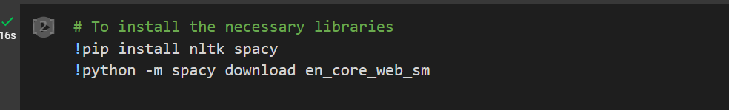

**Step-2:**

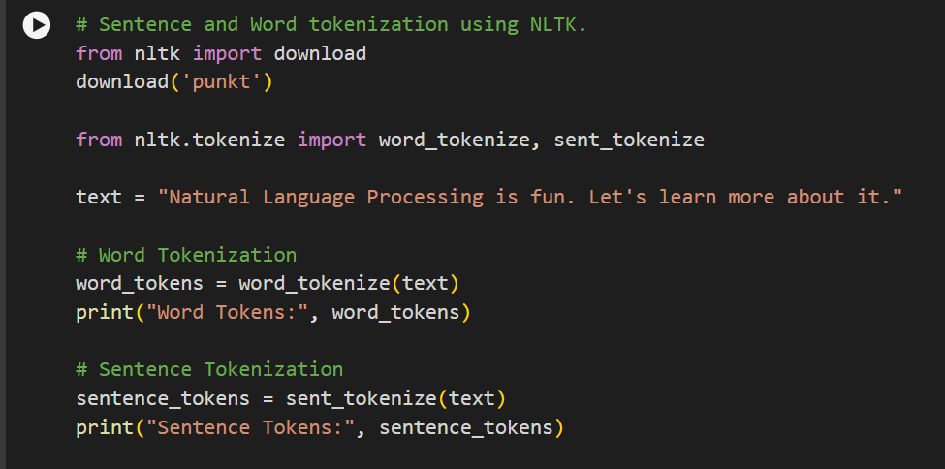

**Step-3:**

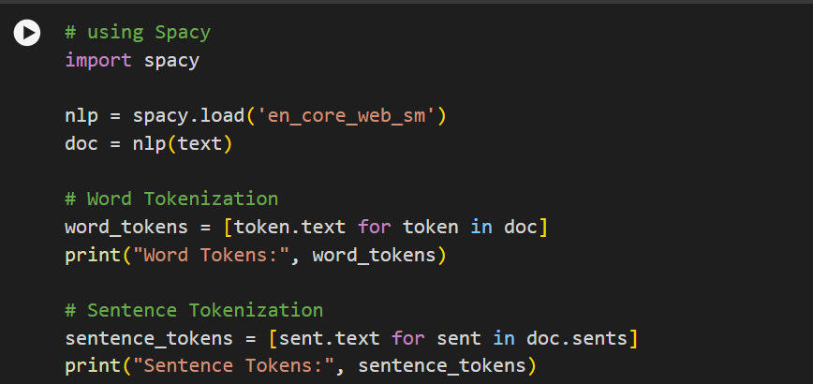

**Step-4:**

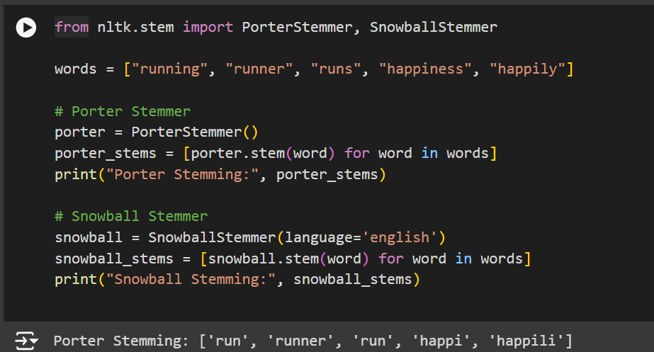

**Step-5:**

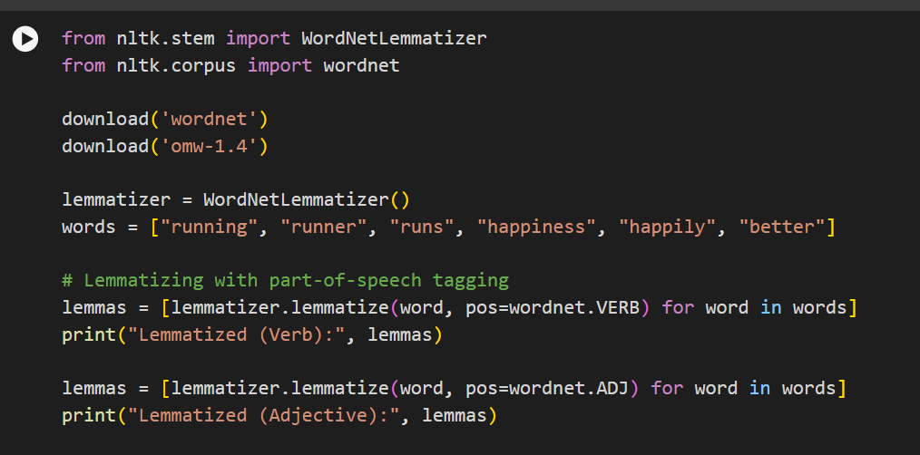

**Step-6:**

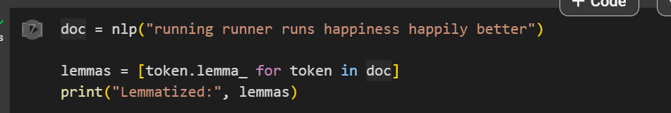

**Output:**







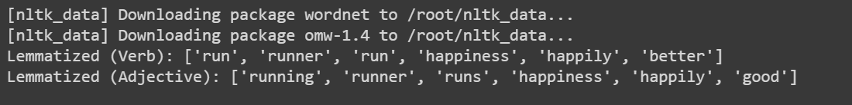



**Assignment Task-02**

**AIM:**

Lab 2 - Python implementation of BoW

**Requirements:**

* Pc/Laptop
* VS Code
* Chrome
* Python installed with sklearn, keras

**Learning Outcome:**

* Understand the implementation of BoW

**Procedure:**

**Step-1:**



**Step-2:**

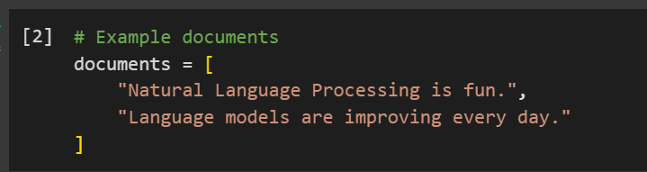

**Step-3:**

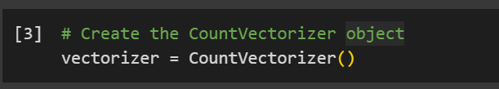

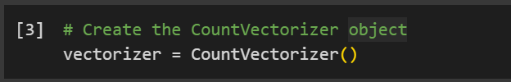

**Step-4:**

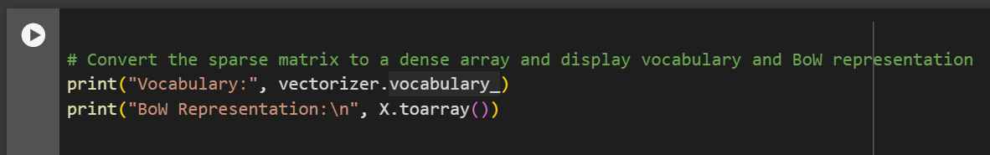

**Output:**



**Assignment Task-03**

**AIM:**

Lab 3 - Python implementation of TF-IDF

**Requirements:**

* Pc/Laptop
* VS Code
* Chrome
* Python installed with sklearn

**Learning Outcome:**

* Understand the implementation of TF-IDF

**Procedure:**

**Step-1:**

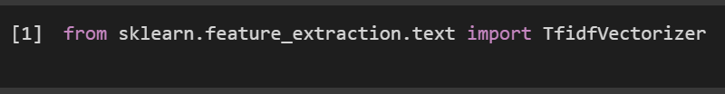

**Step-2:**

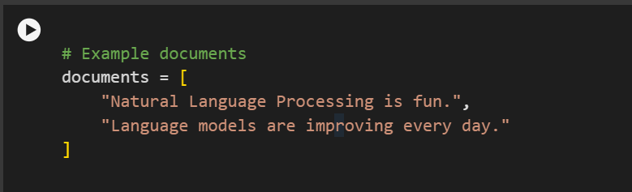

**Step-3:**

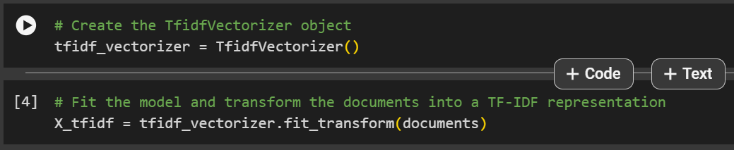

**Step-4:**



**Output:**

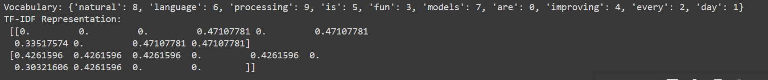

**Assignment Task-04**

**AIM:**

Lab 4 - Python Implementation for Word Embeddings using Word2vec

**Requirements:**

* Pc/Laptop
* VS Code
* Chrome
* Python installed with gensim, scipy, nltk

**Learning Outcome:**

* Understand the Implementation for Word Embeddings using Word2vec

**Procedure:**

**Step-1:**

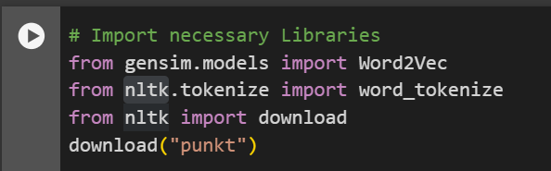

**Step-2:**

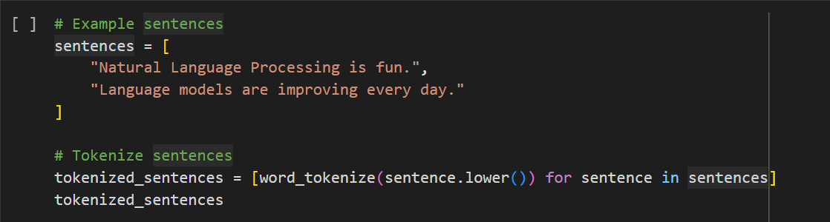

**Step-3:**

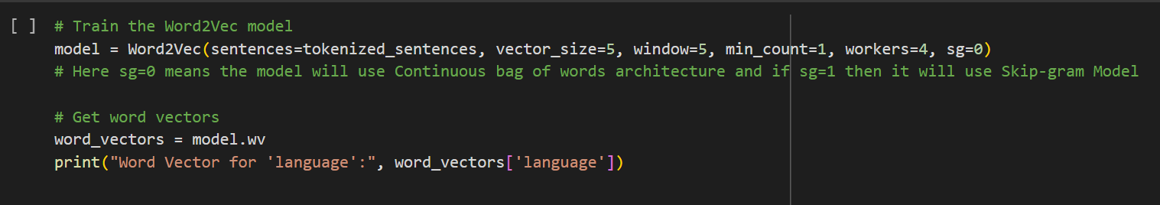

**Output:**

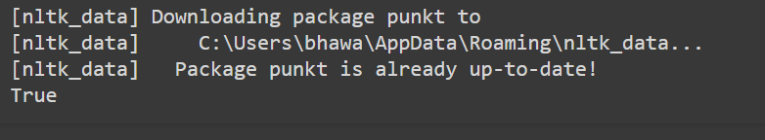

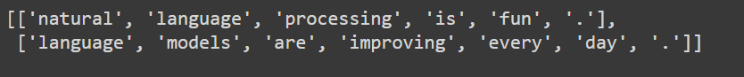



**Assignment Task-05**

**AIM:**

Lab 5 - Python Implementation for Word Embeddings using GloVe

**Requirements:**

* Pc/Laptop
* VS Code
* Chrome
* Python installed with gensim, scipy

**Learning Outcome:**

Understand the Implementation for Word Embeddings using GloVe

**Procedure:**

**Step-1:**

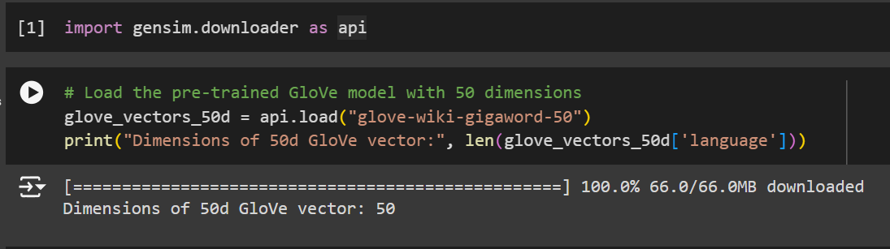

**Step-2:**

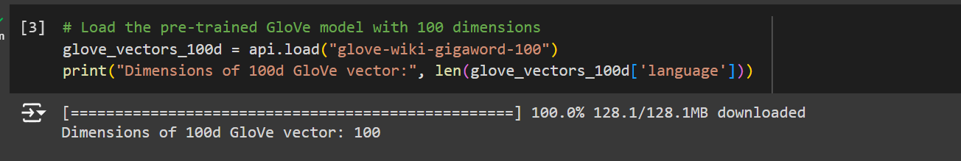

**Step-3:**

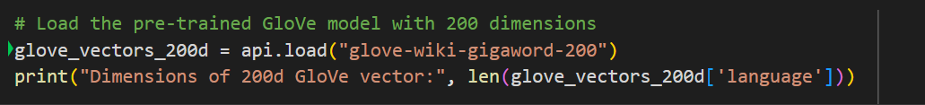

**Step-4:**

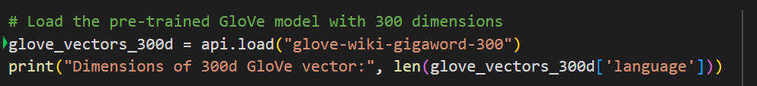

**Output:**









**Assignment Task-06**

**AIM:**

Lab 6 - Python Implementation for Word Embeddings using Fasttext

**Requirements:**

* Pc/Laptop
* VS Code
* Chrome
* Python installed with gensim, scipy

**Learning Outcome:**

Understand the Implementation for Word Embeddings using Fasttext

**Procedure:**

**Step-1:**

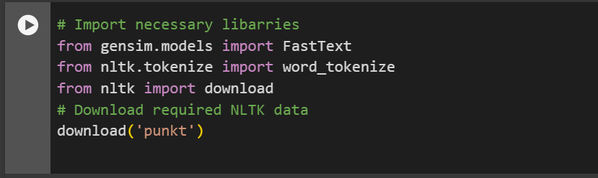

**Step-2:**

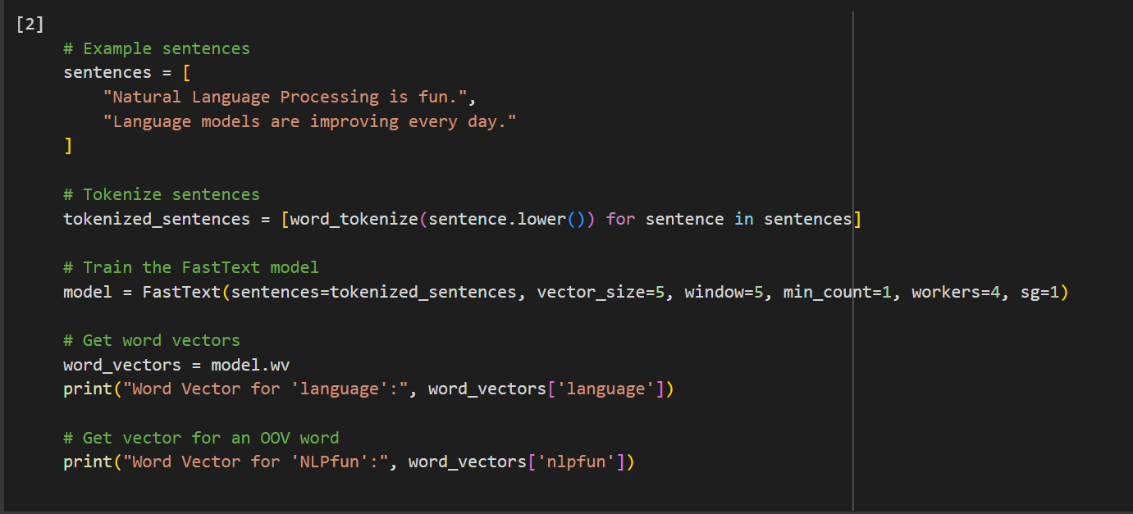

**Output:**



